# Setup Instructions

5/2/2024

You must have a Microsoft Azure account with an Entra user having sufficient authorizations to create users, groups, and applications.

Register a new application in your Azure domain.

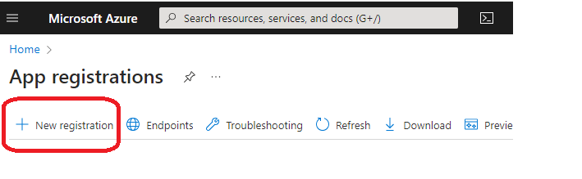

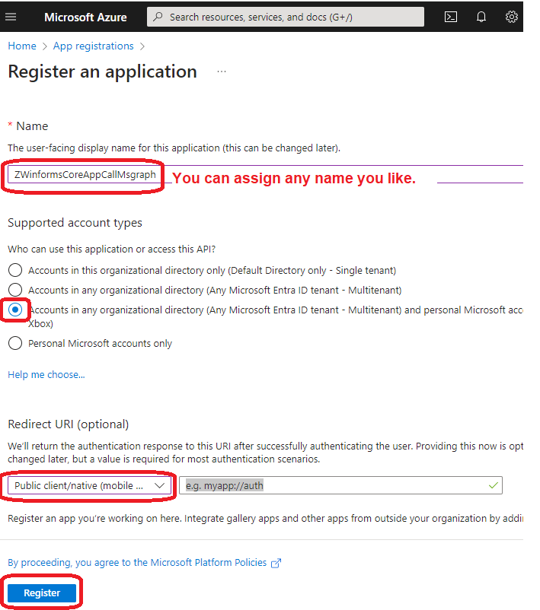

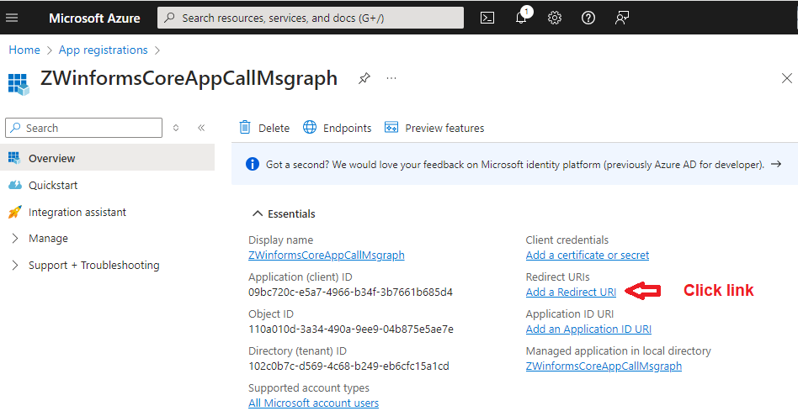

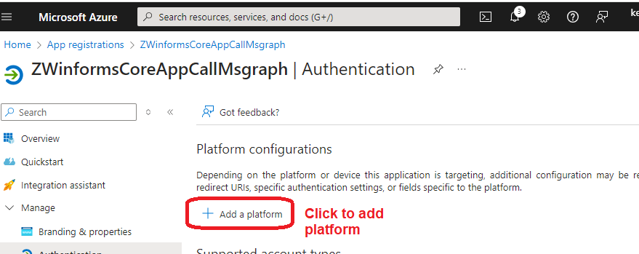

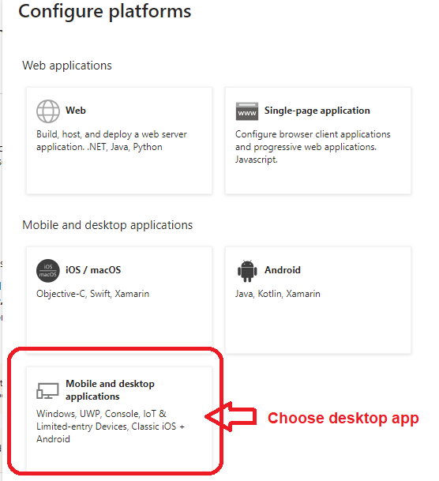

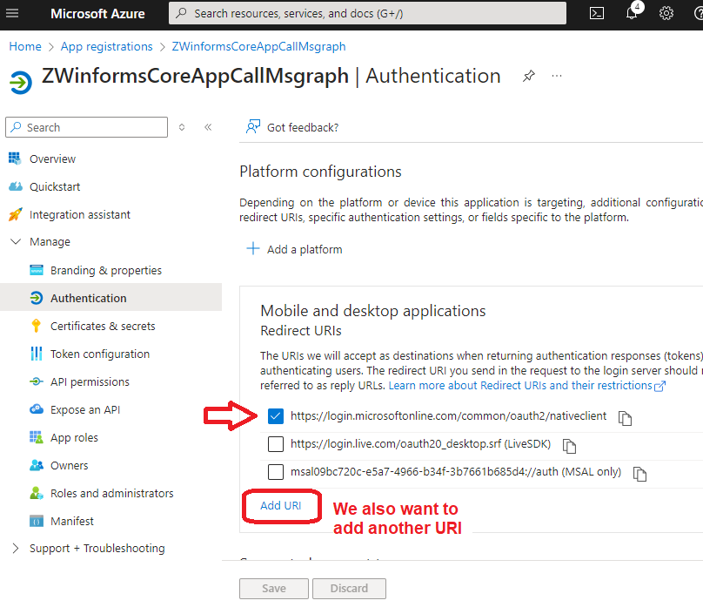

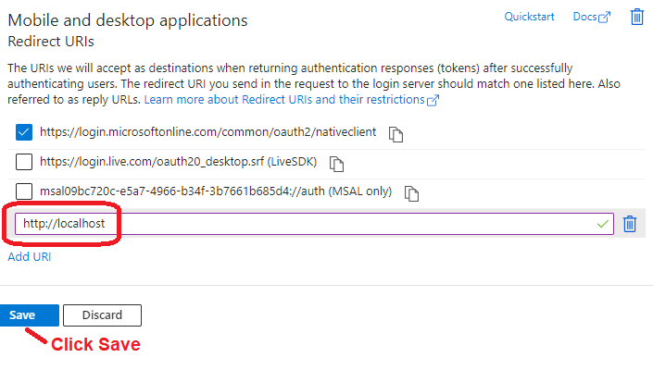

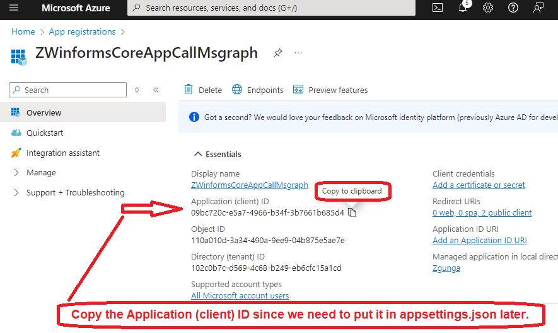

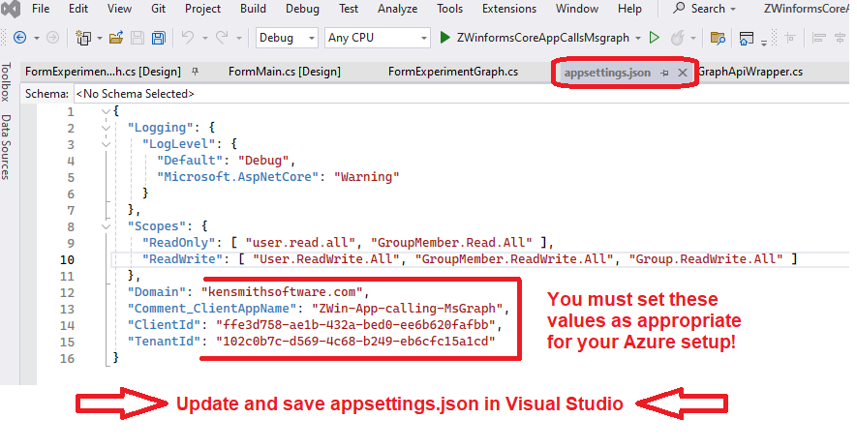

## Now we must create users and groups in Azure Entra as shown in this scenario.

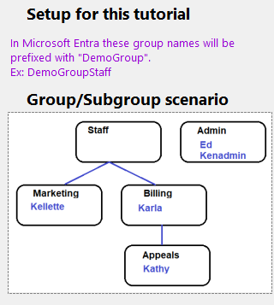 Note that I prefer to avoid subgroups in my environment, but this tutorial demonstrates how subgroups can be used for authorization (using transitive group membership).

### You can create these manually or use the provided Powershell script (KenSetupWinformCallsMsgraph.ps1).

If you use the Powershell script you must change the values for variables $DomainName and $InitialPW.

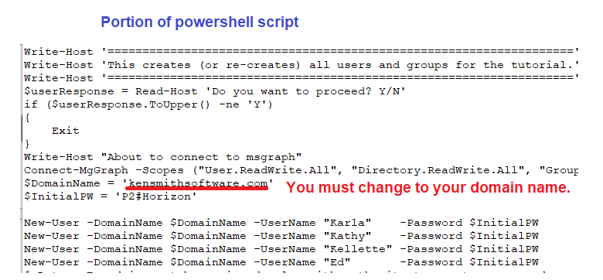

## Assign Enterprise Application Permissions

The simplest way to get the required permissions is to follow these steps:

Step 1: Start the winforms application and select the Read/Write scopes

Step 2: Sign-in with a user whose roles include Global Administrator (lower level roles may be sufficient).

Step 3: As you try functions in the app, you will encounter popups like the one shown below. Click Accept with Consent on behalf of your organization.

